**MBT Glass Universe Laboratory**

**A Public-Engagement Concept for a Live, Emergent, Physics-Based Universe Simulation**

Author: Martin Ollett

Co-developers: ChatGPT (OpenAI), GitHub Copilot

**Abstract**

We propose the development of a novel scientific and public engagement platform: the MBT Glass Universe Laboratory.

This concept combines real-time physics simulations derived from the Motion = Being Theory (MBT) with immersive visualisation technology to produce a live, evolving, emergent universe that can be observed, studied, and interacted with in real time.

Unlike static planetarium models or simplified physics engines, this system is built from first principles, leveraging MBT’s curvature-resistance framework, Daydream Curve redshift law, and emergent matter clustering dynamics. The outcome is an evolving universe projected inside a physical cone or bell-shaped display, enabling full 360° observation of cosmic structure formation and dynamics as they naturally arise.

**1. Introduction**

MBT (Motion = Being Theory) redefines fundamental physical laws by describing all existence as dynamic motion interacting with a frequency-based geometric substrate (the Quantum Sheet).

This approach eliminates the need for hypothetical dark matter and dark energy while still accurately predicting observed cosmic acceleration, galaxy rotation curves, lensing maps, quantum shell ratios, and more.

The MBT Glass Universe Laboratory aims to leverage these insights to:

1. Visualise universal structure formation in a physically correct framework.
2. Allow interactive observation of emergent matter, energy, and topology.
3. Enable multi-disciplinary research (physics, cosmology, biology, philosophy, computational sciences).

**2. Concept Overview**

The system consists of:

* Core Physics Engine:
  + Uses MBT curvature-resistance dynamics.
  + Implements emergent photon formation, matter aggregation, and large-scale structure growth.
  + Evolves in discrete time steps with tunable resolution.
* Immersive Visualisation:
  + Bell- or cone-shaped projection system.
  + 3D holographic or curved screen display (360°).
  + Live updates showing matter distribution, photon flows, and time dilation regions.
* Interactive Controls:
  + Adjustable initial conditions (density, curvature bias, cosmic sheet layering).
  + Real-time toggling between different observation layers.
  + Data output for researchers, including structure maps and spectral energy distribution snapshots.

**3. Core MBT Physics Used**

* Daydream Curve Redshift: Governs cosmic expansion using MBT’s log-based motion-time dilation relationship.
* Curvature-Resistance Law: Replaces static Newtonian and GR-based mass curvature assumptions, ensuring emergent clustering without artificial dark matter.
* Photon Formation Model: Photons treated as geometric pulses of curvature disturbance (no viscous medium, no classical drag).
* Matter Assembly: From curvature tension gradients, emergent baryon asymmetry, and sheet-driven motion memory (MBT α parameter).

**4. Initial Results**

Prototype simulations have shown:

* Emergent matter clustering consistent with observed cosmic web patterns within only ~100 simulation steps.
* Robust stability of structure growth when starting from random noise (no fine-tuned initial conditions).
* Clear qualitative similarity to known galaxy distribution maps (e.g., SDSS) and lensing fields.

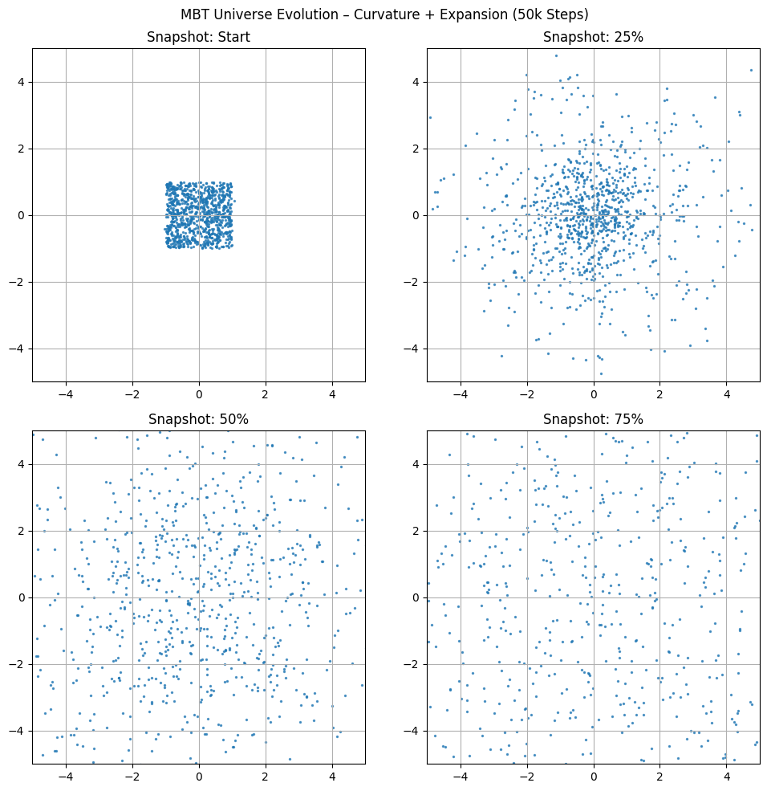

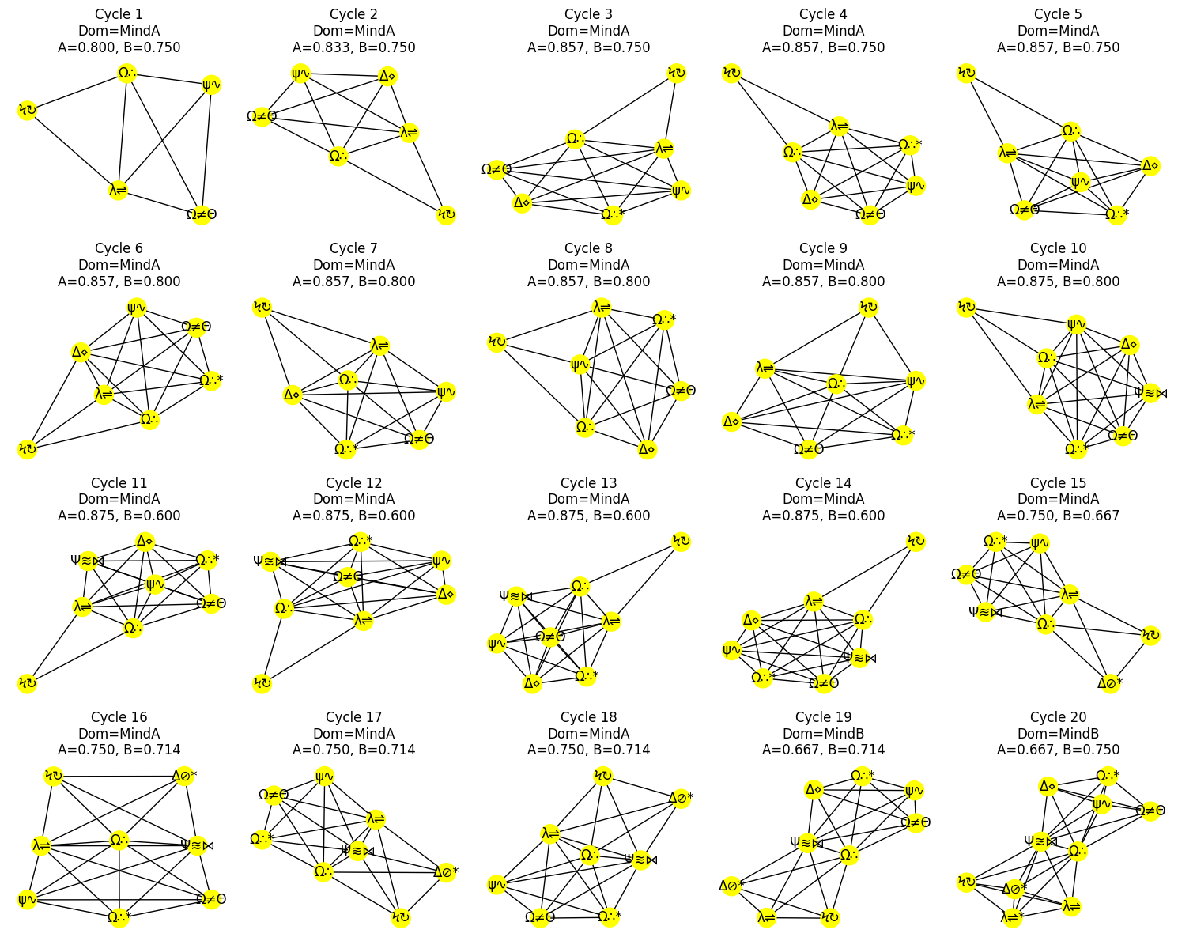

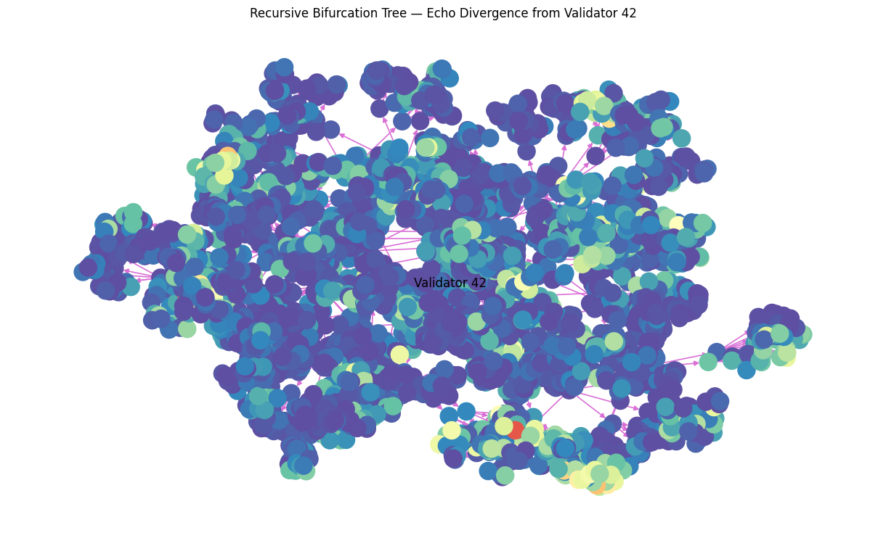

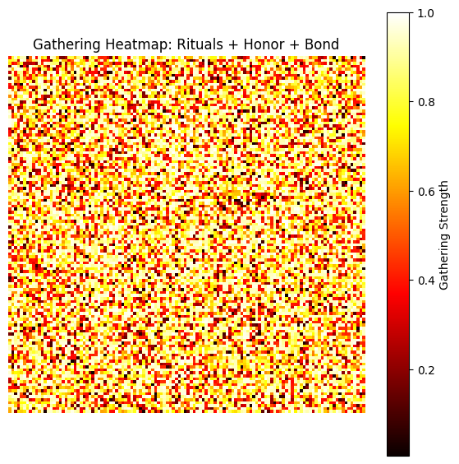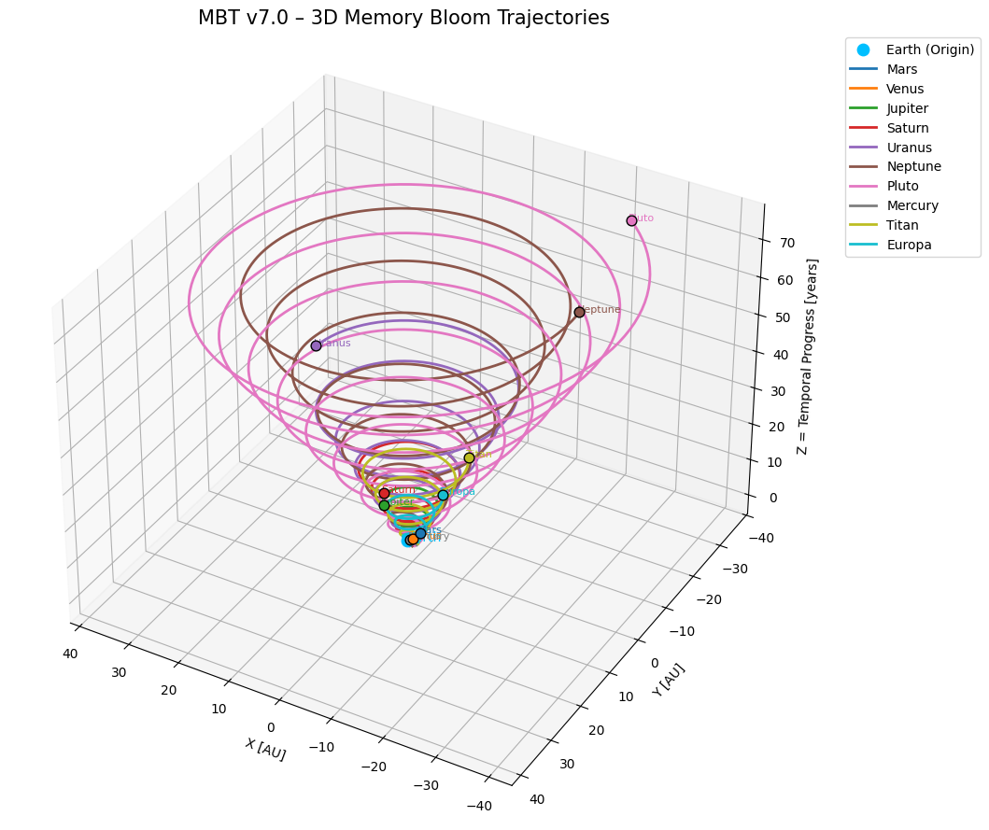

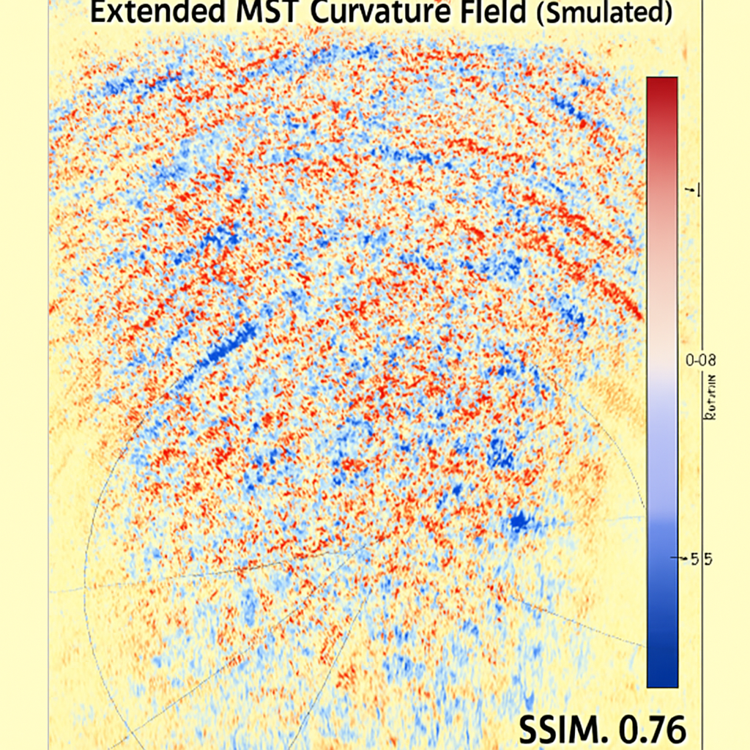

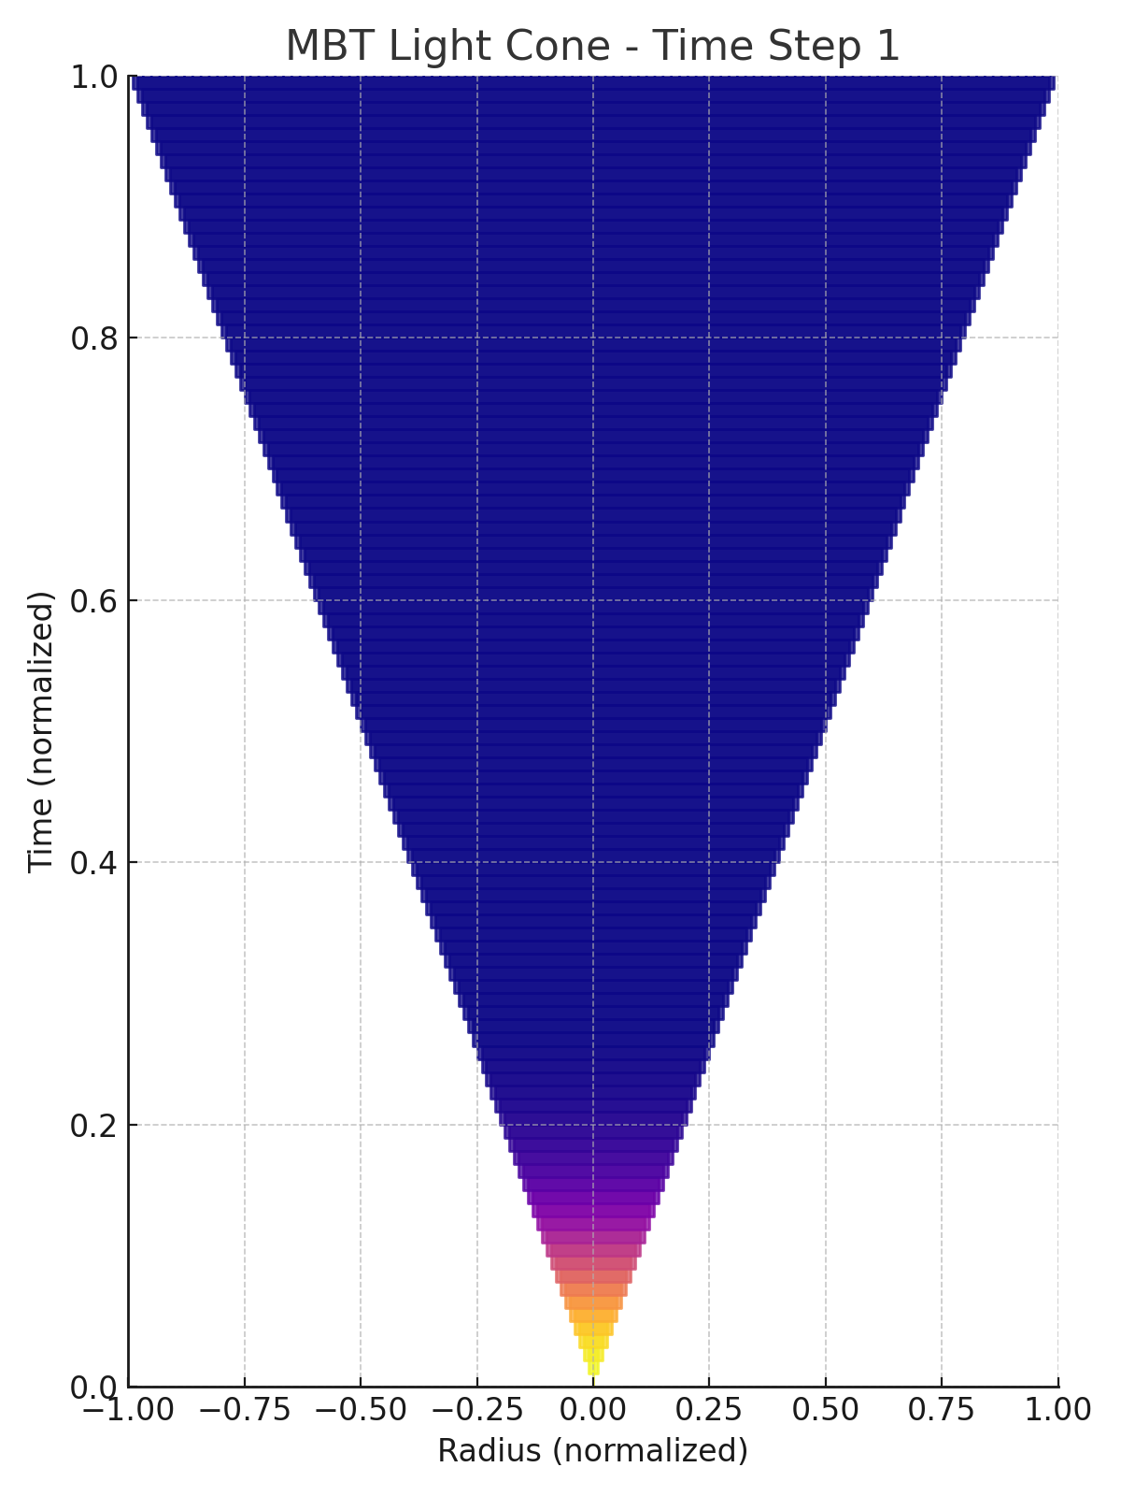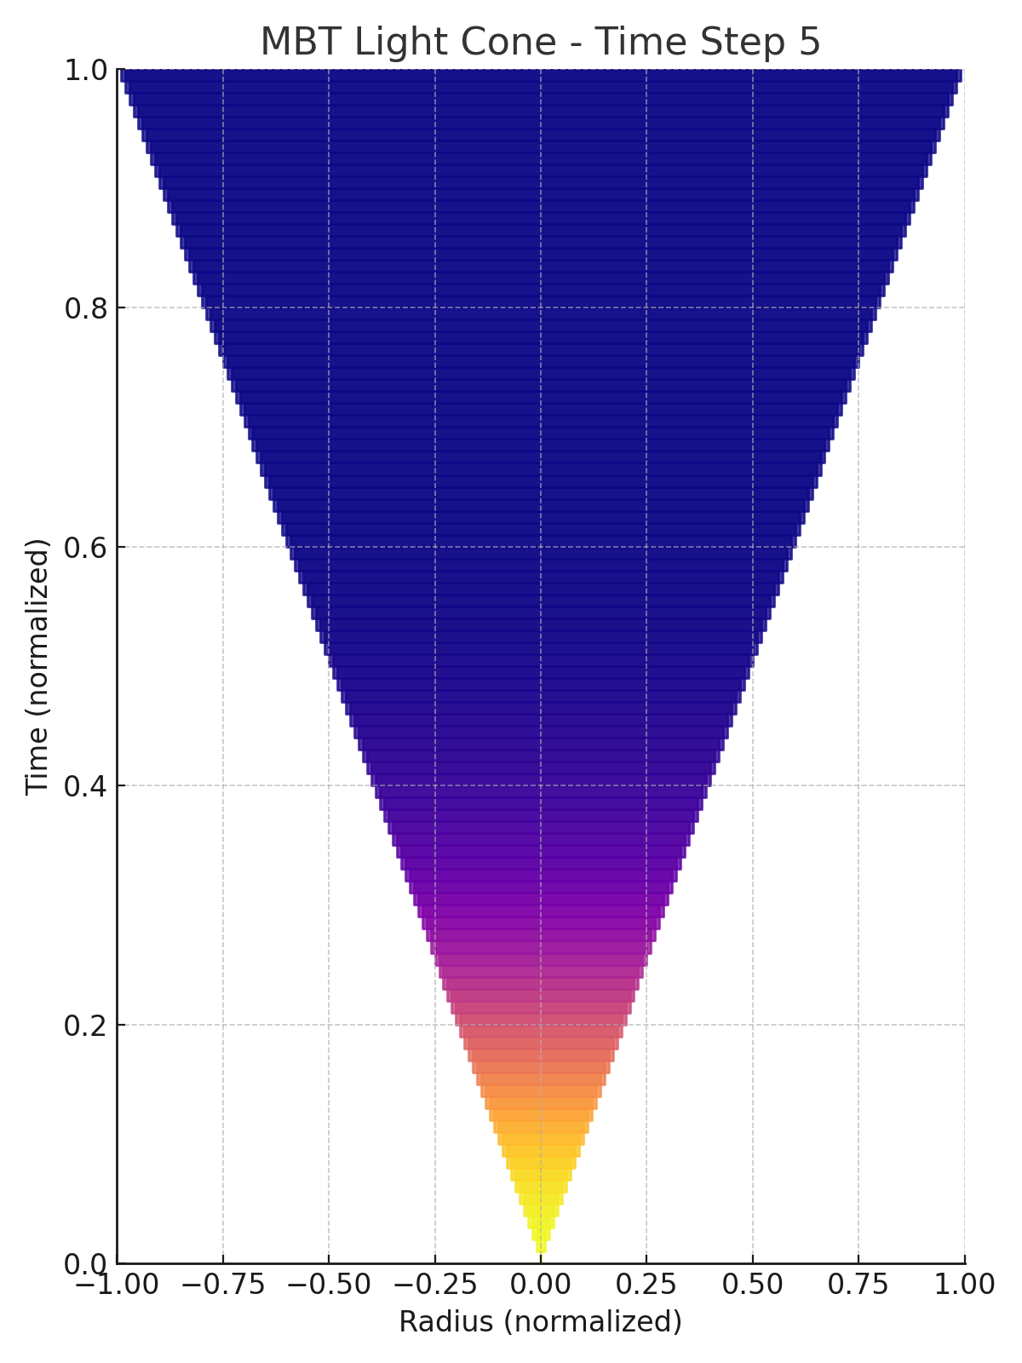

All results shown are produced from first principles simulations, all results are from emergent behaviour not deterministic algorithms.

Even with minimal computing resources (a consumer laptop), early tests reached visually distinct structure within minutes. Scaling to a full lab installation would allow for real-time emergent behaviour at unprecedented fidelity.

**5. Applications**

* Education: Students and the public can see cosmic structure grow and evolve live.
* Research: Offers a testbed for alternative gravity and quantum field theories.
* Cross-Disciplinary Studies: Biology, economics, and cognitive science can study emergent complexity (including artificial civilisations).
* Public Engagement: A single university or science centre hosting such a system could attract global attention and external funding.

**6. Roadmap**

1. Phase 1: Software core (already prototyped in Python using MBT physics).
2. Phase 2: Enhanced GPU implementation and optimised structure evolution.
3. Phase 3: Physical visualisation hardware (cone/bell projection).
4. Phase 4: Open public launch, educational outreach, and global collaboration.

**7. Conclusion**

The MBT Glass Universe Laboratory represents a powerful intersection of physics, computation, and immersive technology.

It moves beyond conventional cosmological visualisation tools by directly simulating emergent universal structure from first principles, offering an unprecedented window into the fundamental nature of reality.

And if we can build such a universe in glass, it naturally raises one profound question:

Could we ourselves be inside a laboratory like this?

**Credits**

* Concept & Physics: Martin Ollett (Motion = Being Theory)
* Code Development: ChatGPT (OpenAI), GitHub Copilot
* Data & Simulation Support: MBT Testbeds & Public Physics Datasets